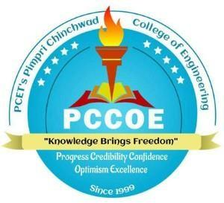

**MINI PROJECT SYNOPSIS**

**Title of the project**



ADITI PALKAR

AJINKYA RAIPURE

SAKSHI ALASHI

ATHARVA KORI

AYUSH KAPSE

DARSHAN BADGUJAR

DIVYA THORAT

(PRN)

123M1H001

123M1H003

123M1H004

123M1H005

123M1H007

123M1H008

123M1H062



Dr Ashwini Ladekar



DEPARTMENT OF MCA

PIMPRI CHINCHWAD COLLEGE OF ENGINEERING SECTOR NO. 26, PRADHIKARAN, NIGDI, PUNE - 44.

(2024 - 2025)

# Index

## Introduction

1. **Problem Statement:**
   * **Working Of Existing System**
   * **Need Of New System**

## Scope of proposed system

## Objectives of proposed system

1. **Methodology**
2. ***Flow diagram followed by description of working***
3. ***Functional Requirements***
4. ***Non-functional Requirements:***

## Technical Requirements

* ***Software requirement***

## Expected Outcomes

## Conclusion

**STUDENT DETAILS**

**Name of Student:**

1. ADITI PALKAR
2. AJINKYA RAIPURE
3. SAKSHI ALASHI
4. ATHARVA KORI
5. AYUSH KAPSE
6. DARSHAN BADGUJAR
7. DIVYA THORAT

**PRN:**

123M1H001

123M1H003

123M1H004

123M1H005

123M1H007

123M1H008

123M1H062

**Email:**

[aditi.palkar23@pccoepune.org](mailto:aditi.palkar23@pccoepune.org)

[ajinkya.raipure23@pccoepune.org](mailto:ajinkya.raipure23@pccoepune.org)

[sakshi.alashi23@pccoepune.org](mailto:sakshi.alashi23@pccoepune.org)

[atharva.kori23@pccoepune.org](mailto:atharva.kori23@pccoepune.org)

[ayush.kapse23@pccoepune.org](mailto:ayush.kapse23@pccoepune.org)

[darshan.badgujar23@pccoepune.org](mailto:darshan.badgujar23@pccoepune.org)

divya.thorat23@pccoepune.org

**Contact No.:**

**7083939090**

**9370550972**

**9834199600**

**9067070540**

**9529620413**

**7218095749**

**9766827173**

# 1.INTRODUCTION

All of that compelling story will be brought to you online for the first time in history.That women in remote areas of India making handicrafts can have an online presence, and be empowered! So good. So this is an online digital branding platform used to empower women, featuring the extravagant diversity of handmade crafts from rich smell cookies aren't bad with a shop in enemy the world over than.

In a word: Life of its own 。Women, weathering commerce and fashion house, a bar, for busy farms and decorative textiles. It also has design tools that are very easy to use even for women with no art training at all; as well as ways of telling stories via pictures or words (and sometimes both in combination); further design and user interface functions available for integration with social media that really allow artisans to tell their stories not just in images or print, but with emotion and passion hooking listeners in

Its goal is to provide women craftspeople with the necessary tools and resources they need, so that it is possible for them to survive in today's economy. Bridging the gap between traditional crafts and high-tech digital business, this project aims not only to teach women artisans how to maintain their livelihoods by working on a global scale but also accelerate it amidst the exceptionally competitive world market.

# 2.PROBLEM STATEMENT

**a. Working Of Existing System:**

* Local Markets: Women artisans commonly sell their products in local markets, fairs, or craft shows. Their typical customer base is often composed of residents in the area or other visitors who just happen to be there. This problem of geography reduces their chances of growth and income exponentially, because the reach was limited to a small population, usually an inconsistent audience.
* Intermediaries: Most of these artisans are compelled to rely upon intermediaries or middlemen who buy craftsman works at very low prices and sell them at higher profit margins. This diminishes not only the earnings that an artisan makes but also takes from them control over pricing and branding, which essentially undervalues the real worth of handmade products.
* Minimal Online Presence: Although some artisans attempt to sell through general e-commerce portals, these are not designed to cater to handmade crafts in particular. Most of these definitely lack features in workmanship and cultural identity for the commodity at large. Moreover, these sites do not provide any support for branding and storytelling and personalized customer engagement—thereby making it hard for artisans to come out distinctively in an overcrowded online marketplace.
* Marketing Limitations: For most of these women, their marketing has only limitedly been word-of-mouth or just plain posting in social media sites to alert people for participation, and is therefore not good enough for world exposure. In turn, such artisans can neither attract nor retain customers, hence impeding them from growing and sustaining their businesses due to a lack of resources and skills to use digital marketing techniques effectively.

**b. Need Of New System**

* Global Reach: On this platform, an artist can bring his or her handiwork so far beyond its homeland frontiers and into the global market.Appearance High Potential For More Sales This option in effect provides channel of market expansion, giving them exposure to sell their crafts far and wide not just among friends but also to customers from all over the world.
* Direct Sales: A platform of this sort, which directly connects artisans with their customers, means that they can keep the asking price where they want it to be and still get a fair wage for their labour providing that service.Establishing this close relationship with customers is what will build trust features though first and foremost it is something that provides an individualized service which aims to please customers.Comprehensive
* Branding Tools: The platform provides a complete set of branding tools, allowing artisans to create and maintain their unique style. With functions such as customized store displays, immersive storytelling and professional photography, artists are enabled to present their products in the best possible light. This serves to enhance both brand recognition for their work, as well as increasing the appeal of that brand itself in general.
* Digital Literacy and Support: A platform that embraces the spirit of the times, it provides full training and support to help artisans manage their online presence properly. Part of this education includes such fields as internet site management, best practices in e-commerce and engagement in social media so as to set out a clear path for success on the digital road of today.
* Targeted Marketing: With its integrated data-driven marketing tools, the platform can reach target audiences of–even if small scale compared with many mass-marketing efforts–genuine passion holders for handmade and traditional crafts. Including personalized customer service during the whole sales process should therefore result in not only better sales figures but greater loyalty toward your brand.
* Sustainability and Growth: Long-term support means that users will always keep up, and constantly improve. This lets artisans go on refining their own business and adaptation to the demands of changing market trends, so that they grow up within an economy which is digital and keeps changing.

# 

# 3. SCOPE OF PROPOSED SYSTEM

The platform aims to become the backbone for the radical change in the interface of women artisans with the global marketplace, management of their brands, and sustaining businesses. This overcomes the shortcomings of a traditional process of selling by equipping the artisans with tools and resources that will help them succeed in this new and burgeoning digital economy.

* Create overseas market: Enable these crafts persons take their markets beyond the local shores by reaching out to an international, very diversified audience. So, the value of such overseas exposure will multiply both their sales prospect as well as market visibility very significantly.
* Enable direct-to-consumer sales: Facilitate the artisans to sell direct to the end customers cutting out the middlemen. In this arrangement, all the money realized on the work will go to the maker-advancing the cause of fair trade and even a real personal relationship with the buyer.
* Complete Branding and Marketing Tools: The tool should be provided to the craftsmen so that they are well-equipped with modern, professional instruments for building and managing their own brand. The site will offer customizable storefronts online, further storytelling facilities, and concentrated marketing efforts to help in garnering utmost exposure and a loyal customer base for the brands.
* Digital literacy and continuous support: individual training with continued support to ensure the artisans achieve minimum competencies associated with the use of digital technologies in managing and developing the online business; that is, e-commerce management, social media use in engaging customers, and customer relations.
* All this would be done by giving the artisans wherewithal and updates at all times, making their business abreast of changing market dynamics and as such, position the business to be competitive, resilient, and capacitated for success in the digital economy.

# 4. OBJECTIVE OF PROPOSED SYSTEM

1.Increased market access: Enable artisans to reach more customers across India, increasing their market exposure.

2. Direct Sales: Provide a platform wherein artisans can sell directly to consumers, improving profit margins that eliminate middlemen and other intermediaries.

3. Branding and Identity: Advanced capabilities that will help artisans create and manage their distinctly quality online storefronts

4. Digital Literacy: Training and expertise in developing the skills of artisans to improve the management of their digital presence and their business.

5. Engage More Customers: Provide relevant marketing and storyline features to enable more potent customer relationships.

6. Sustainable Business Growth: Empower Artisans: Offer continuous support and resources for artisans to adapt to the market and keep up with their success over time.

7. Optimize Operations: Ensure smoothening of product management, order fulfillment, and analytics for better operational efficiency.

# 5.METHODOLOGY

1. ***Flow diagram followed by description of working***

* Flowchart for demonstrating the workflow to be performed in

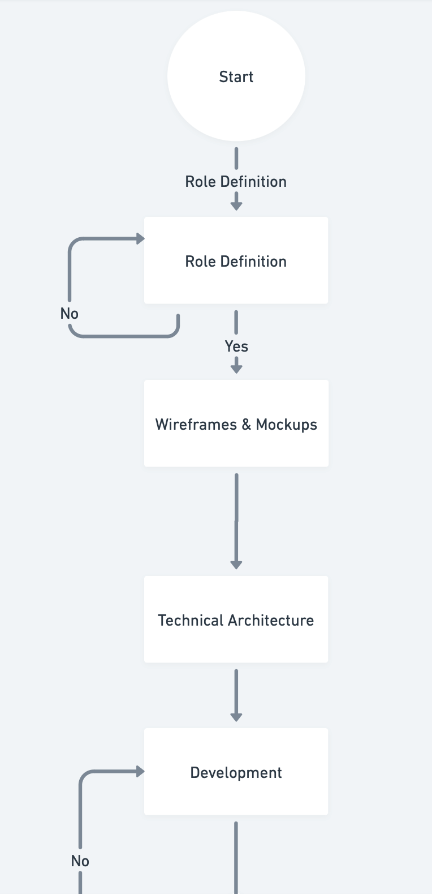

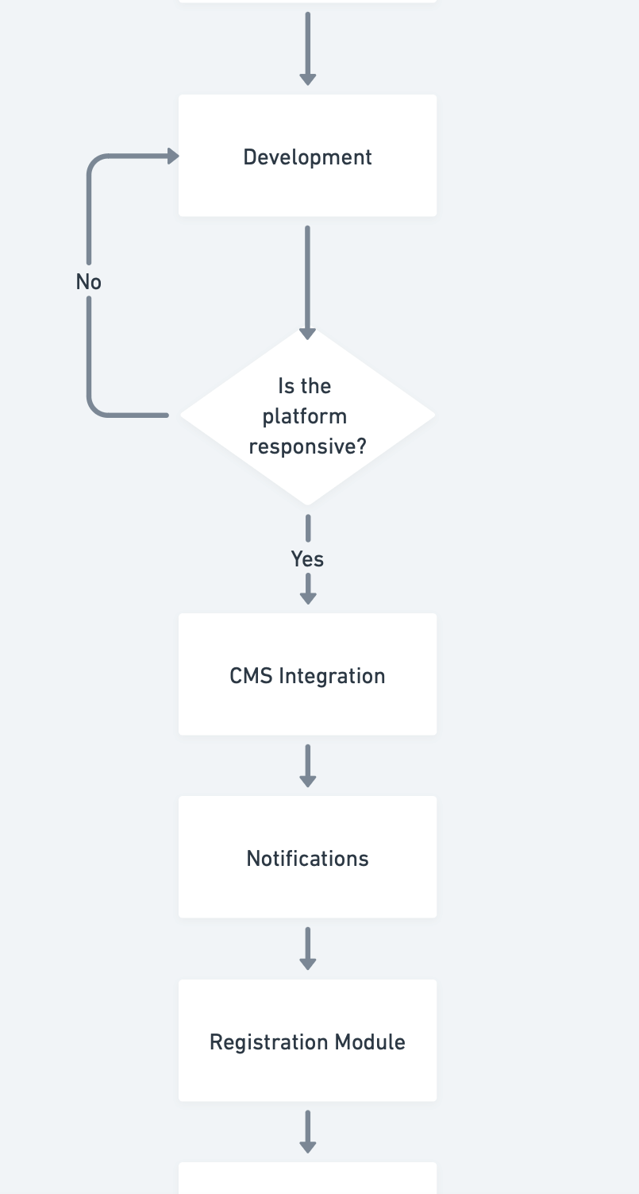

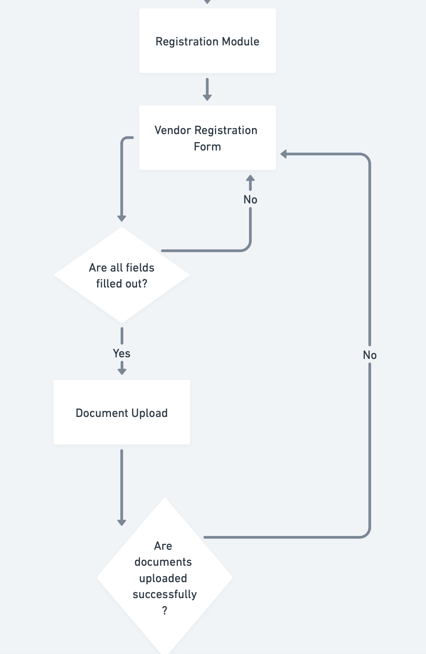

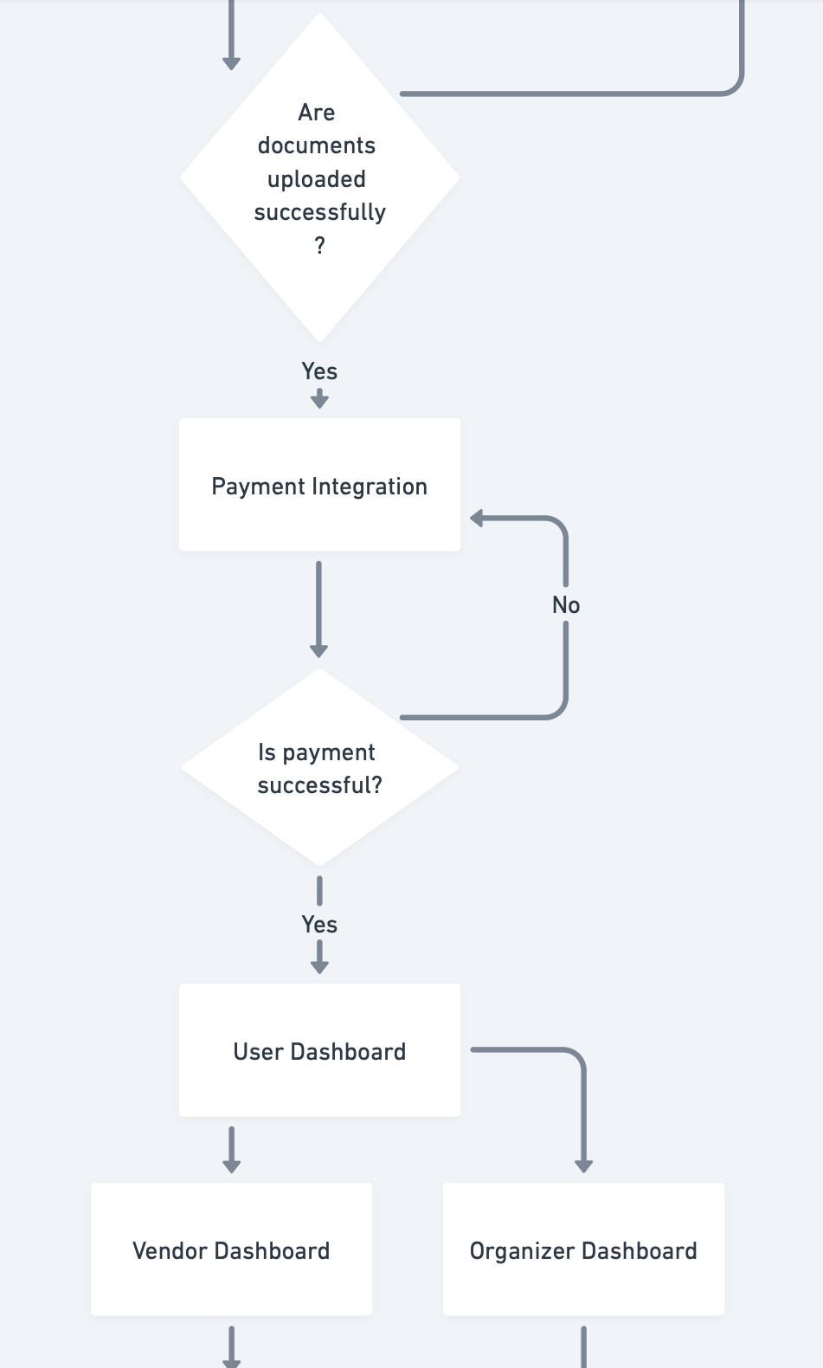

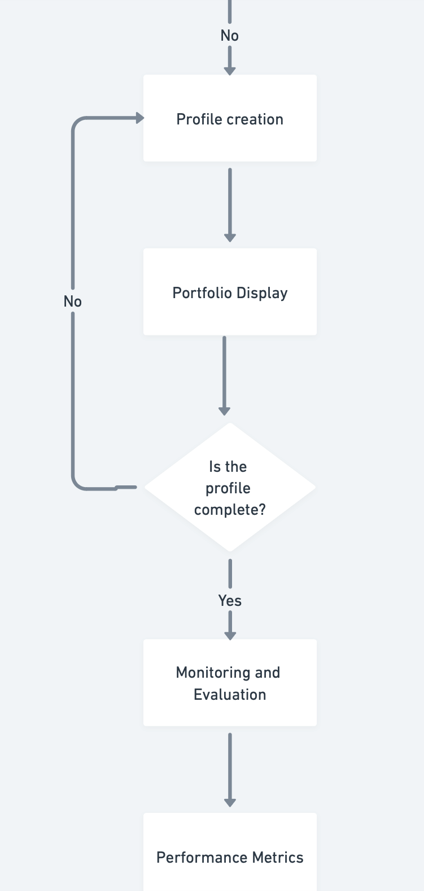

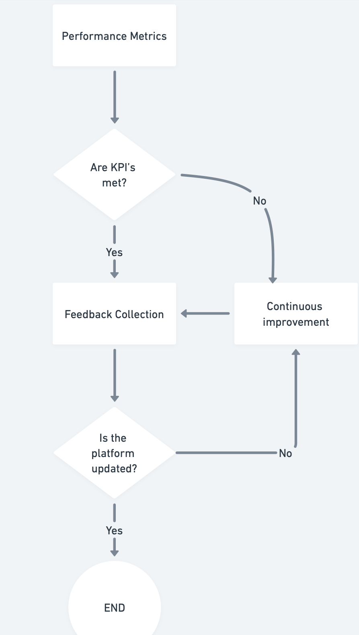

1. ***Functional Requirements:***

1.User Accounts: Registration and profile management for artisans and customers

2. Customizable Storefronts: Tools to help artisans create an online storefront and its design process

3. Product Management: Add, manage, inventory, and update products.

4. Shopping Cart & Checkout: Multi-payment, safe cart and checkout system

5. Order Tracking: Features for artisans to manage and track orders; features for customers to track their purchases.

6. Branding Tools: Options for sharing artisans' brand stories and integration of social media

7. Marketing Tools: Email marketing, social media integration, and promotional features

8. Analytics: Sales and customer behavior reports; marketing performance reports

9. Training & Support: Learning resources and customer support for digital skills and how to use the platform

10. Multilingual & Multicurrency: The various languages and currencies to be supported

11. Security: Protection and privacy protection for data

12. Mobile Responsiveness: Allow access and compatibility with mobile devices***.***

1. ***Non-functional Requirements:***

1.Performance: fast response times, scalability to growing users and transactions.

2. Reliability: high availability, fault tolerance with very minimal downtime.

3. Usability: feel—the user interface is intuitive and accessible to all users.

4. Security: robust data protection, compliance with the existing regulations on data privacy.

5. Maintainability: well-documented, modular code that allows easy updating and maintenance.

6. Scalability: The system can scale both horizontally and vertically according to the need.

7. Backup and Recovery: A scheduling of regular data backups and a disaster recovery plan.

8. Interoperability: Integration with third-party services and platforms.

9. Legal Compliance including e-commerce and consumer protection legislation.

# 

# 6. TECHNICAL REQUIREMENTS

1. Platform Overview

A user-friendly website that helps women artisans showcase and sell their crafts online.

2. Software Requirements

2.1 Frontend

- Technology: Use HTML, CSS, and JavaScript for building the website.

- Framework: React.js for creating interactive pages.

- Design: Use Bootstrap or Tailwind CSS to make the site look good on any device.

2.2 Backend

- Database: Use MYSQL to store data like user profiles, products, and orders.

- Security: Use basic authentication (email and password) to protect user accounts.

2.3 Payment Integration

- Payment Gateway: Use Stripe or PayPal to handle online payments.

2.4 Analytics

- Tracking: Use Google Analytics,Kaggle and POWERBI/Tableau to see how many people visit the site and what they do.

2.5 User Support

- Contact Form: Include a simple contact form for users to ask questions or get help.

# 7. EXPECTED OUTCOMES

1.National Market Expansion: The artisans will now reach a wider market all over India, improving local market opportunities.

2. Increase in Revenue: This strategy, in the short term, of direct-to-consumer selling will increase the earning capacity of artisans by eliminating intermediaries.

3. Better Branding: Tools for the development of robust and recognizable brands in India will be provided to the artisans.

4. Better Digital Skills: Training and support to manage online presence and business-related activities better will be provided to the artisans.

5. More Customer Engagement: Targeted marketing features will foster stronger connections with Indian consumers.

6. Sustainable Growth: Continued help to the artisans to cope up with the market trends and long-lasting success.

7. Operational Efficiency: Streamlined processes will bring in more efficiency in management and decision making for artisans.

8. Localized User Experience: Easy and secure single window platform developed exclusively for Indian Artisans and their customers.

# 8.CONCLUSION

The Digital Branding Platform for Women Artisans would make the most impact by empowering every woman artisan of the country with the arsenal required for success in this digital age. Essentially, it provides an integrated solution to some of the major challenges confronted by artisans in accessing markets, branding their business, and managing the latter in order to reach further markets and make the best use of opportunities.

It will enable artisans to sell unique products to much larger markets while still holding much greater control over their profits, through direct-to-consumer sales with advanced branding and marketing tools. Further facilitation of this shall come from being strongly integrated in and supportive of training in, and support of, digital skills for the artisans so they can effectively operate and scale their online presence.

It's therefore anticipated that integration of targeted marketing into streamlined operational processes will result in increased efficiencies and better customer relationships, thus leading to long-term loyalty and general success. This development aims to create a strong, resilient ecosystem of women artisans who will ultimately bring together the richness of their cultural heritage and the dynamic digital economy.

Basically, therefore, it means the Digital Branding Platform stands as a step toward women artisans' economic empowerment and business growth to entrench them for continued success and prominence within markets.